**RIPHAH INTERNATIONAL UNIVERSITY, ISLAMABAD**



**Lab 10**

**Bachelors of Computer science – 6th semester**

**Subject:** Artificial Intelligence Lab

**Submitted to:** Ma’am Ayesha

**Submitted by:** Munaza Malik

**Sap Id:** 44956

**Date:** 15th April, 2025

**LAB TASKS**

**Task 1:**

Implement KNN classifier with Iris dataset.

**Code:**

import numpy as np  
from sklearn.datasets import load_iris  
from sklearn.model_selection import train_test_split  
from sklearn.metrics import classification_report  
from collections import Counter  
  
iris = load_iris()  
X, y = iris.data, iris.target  
  
X_train, X_test, y_train, y_test = train_test_split(X, y, test_size=0.2, random_state=42)  
  
class KNearestNeighbors:  
 def __init__(self, k=3):  
 self.k = k  
  
 def fit(self, X_train, y_train):  
 self.X_train = np.array(X_train)  
 self.y_train = np.array(y_train)  
  
 def _calculate_distance(self, point1, point2):  
 return np.sqrt(np.sum((point1 - point2) ** 2))  
  
 def predict(self, X_test):  
 return [self._predict_single(sample) for sample in X_test]  
  
 def _predict_single(self, sample):  
 distances = [self._calculate_distance(sample, train_sample) for train_sample in self.X_train]  
 nearest_indices = np.argsort(distances)[:self.k]  
 nearest_labels = [self.y_train[idx] for idx in nearest_indices]  
 return Counter(nearest_labels).most_common(1)[0][0]  
  
knn_model = KNearestNeighbors(k=3)  
knn_model.fit(X_train, y_train)  
  
y_pred = knn_model.predict(X_test)  
  
accuracy = np.mean(y_pred == y_test)  
print(f"Model Accuracy: {round(accuracy * 100, 2)}%")  
  
print("\nClassification Report:")  
print(classification_report(y_test, y_pred))

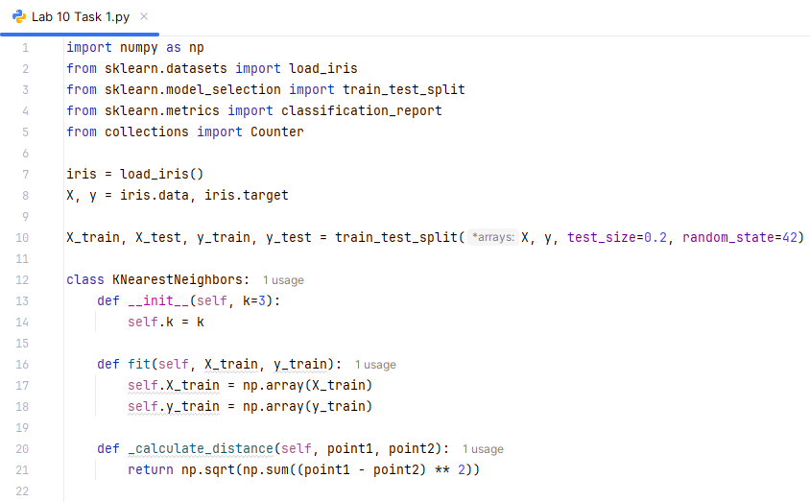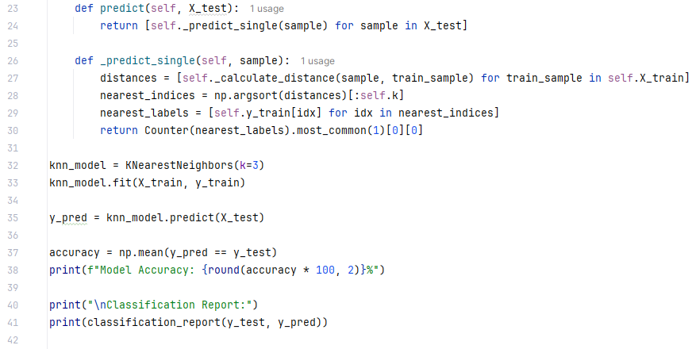

**Output:**

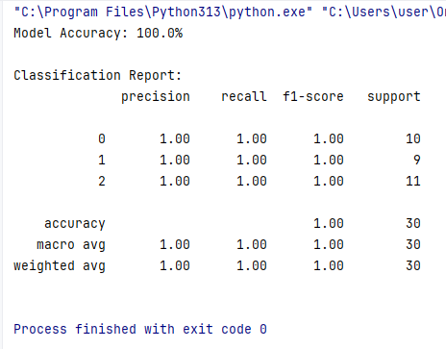

| **sepal length** | **sepal width** | **petal length** | **petal width** | **target** |
| --- | --- | --- | --- | --- |
| 5.1 | 3.5 | 1.4 | 0.2 | 0 |
| 4.9 | 3.0 | 1.4 | 0.2 | 0 |
| 4.7 | 3.2 | 1.3 | 0.2 | 0 |
| 4.6 | 3.1 | 1.5 | 0.2 | 0 |
| 5.0 | 3.6 | 1.4 | 0.2 | 0 |
| ... | ... | ... | ... | ... |
| 6.7 | 3.0 | 5.2 | 2.3 | 2 |